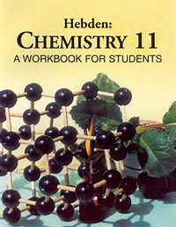 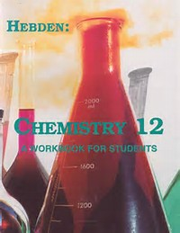

**WESTERN CAMPUS RESOURCES INC.**

Your source for Hebden Chemistry

The Jim Hebden 2025 Chemistry Bursary

Applications are open until May 9th, 2025 for a $1000 bursary that recognizes excellence in the study of chemistry and community service.

Further details are found at [www.WesternCampus.ca](http://www.WesternCampus.ca)

Sponsored by the exclusive distributor of the Hebden Chemistry Workbooks 11 & 12

Western Campus Resources Inc.

Do you have science books you no longer use?

To sell used science books or to order Hebden Chemistry Workbooks, please contact [info@WesternCampus.ca](mailto:info@WesternCampus.ca)

Jim Hebden & Western Campus Resources thank teachers for helping students complete their applications.

Note: The recipient of this bursary need not attend a school that uses Hebden Chemistry Workbooks.

Western Campus Resources has supplied used Western Campus Resources Inc.

Science textbooks to Canadian K-12 schools since 1114 East 3rd Street

1997. The company is locally owned and operates North Vancouver, BC V7J 1B8

from North Vancouver 604-988-1055/1-800-995-5283